|  |  |
| --- | --- |
| Sustainable development goals  SDG assignment | Nathany boekhoudtenvironmental scienceuniversity of arubayear 2017 |

# Contents

Describe what SDG target and goal your indicator is monitoring, and how 2

Why is this SDG target and goal important to Aruba? 2

How does this SDG target and goal relate to waste management in Aruba? 3

Indicators monitoring 3

statistics 4

Bibliography 8

# Describe what SDG target and goal your indicator is monitoring, and how

My sustainable development goal is the 3rd goal: Good health and wellbeing. It’s **targets** are:

* 3.7)*“By 2030, ensure universal access to sexual and reproductive health-care services, including for family planning, information and education, and the integration of reproductive health into national strategies and programmes”   
  🡪*This target is to try educate women about family planning, provide health care and programmes. I believe this goal is to reduce unplanned pregnancies or teen pregnancy. They want to do this through health care programs, education, giving information and imply strategies to oppose this. They monitor this via the need of modern methods women between the age of 15-49 use for family planning and the teen pregnancies in the years of 10-14 and 15-19.
* 3.8) *“Achieve universal health coverage, including financial risk protection, access to quality essential health-care services and access to safe, effective, quality and affordable essential medicines and vaccines for all”*.

🡪This target is to achieve health care coverage for the people. To try and improve the health care system where people, including the disadvantaged ones, don’t have to be provide for their own health care. They monitor this on controlling if health care providers cover essential health service for general and disadvantaged people. Also, by how many people are covered by health care and insurance.

# Why is this SDG target and goal important to Aruba?

Aruba is a really small island, so it’s more vulnerable to diseases since it’s easier to spread. So the prevention of HIV//AIDS and other diseases is really important. In order to do this education is the key, through providing information about this.   
Teen pregnancy is becoming a common thing in Aruba and most of these children suffer from neglect later on because their parents have to work extra hours. I believe this goal is important to lessen teen pregnancy, offer more education about health, provide health care for our people.   
Because of the small size of Aruba, resources are limited, there is not enough well educated doctors, not enough medicine and not enough technology. They need to send a lot of people out there to Bucaramanga, Curacao or Bogota. Health care provides for this medical trips, however it’s time limited. This is why it’s important to have health care systems that can cover these expenses. For example: Baby Luna. They had to make a foundation to raise money to cover her expenses.

# How does this SDG target and goal relate to waste management in Aruba?

Waste management can help health care organization makes more efficient decisions to reduce costs. Medical products are expensive but still high in demand, so whatever the costs is, you still need to purchase this. Waste management can contribute to giving a more intelligent way of using products and introduce recyclable products that can be used in the medical area. In Aruba there is barely room for people in the hospital. If we can find a way to manage the energy use, if we can run on renewable energy, we can save costs. In the long run with the money that you’ve saved it’s enough to build another hospital that also runs on renewable energy.   
Due to the lack of proper waste management in Parkietenbos, the residents around this area are exposed to all the gases that vaporize in the air. These people are going to be affected in the long run. Women who were pregnant, and are exposed to this can also get children with birth defects. A good stable health care system can take this situation and solve it.

# Indicators monitoring

**-Proportion of women of reproductive age (aged 15-49 years) who have their need for family planning satisfied with modern methods** 🡪 Famia Planea offers modern methods to family planning if you are a member, they save your information in their data and you pay less for birth controls.

**-Adolescent birth rate (aged 10-14 years; aged 15-19 years) per 1,000 women in that age group.** CEMBRAH, which is a part of Wit Gele Kruis, keeps up to date with teen pregnancies. Wit Gele Kruis gathers information about these young women and often do house visits to check the progress of the teen mother.

**-Coverage of essential health services ( include reproductive, maternal, newborn and child health, infectious diseases, non-communicable diseases)  
Number of people covered by health insurance or a public health system per 1,000 population**🡪 both of these indicators are monitored by AZV. AZV provides access to health care in Aruba. It provides education for a healthy life and provides specialists for patients who need.   
Links:  
[**SDG Aruba**](http://sdgaruba.com/sdgs/health/)[**Wit Gele Kruis**](https://www.google.com/url?sa=t&rct=j&q=&esrc=s&source=web&cd=1&cad=rja&uact=8&ved=0ahUKEwir44zQoK_XAhVCPiYKHesuD4IQFggnMAA&url=https%3A%2F%2Fwww.witgelekruis.be%2F&usg=AOvVaw2PihXNcwZCWXFz0CayoE1W)[**AZV**](http://www.azv.aw/)

# statistics

The highest age groups of females in Aruba are at the age between 5 and 19 and between 40 and 54 years of age.

The age group between 20 and 39 years of age is smaller thus this will impact the amount of newborns in the coming years. Fertility rate will decline because of this.

Hence why there are a lot of teenage pregnancies since most women of Aruba are either fertile young adults or unfertile matured women.

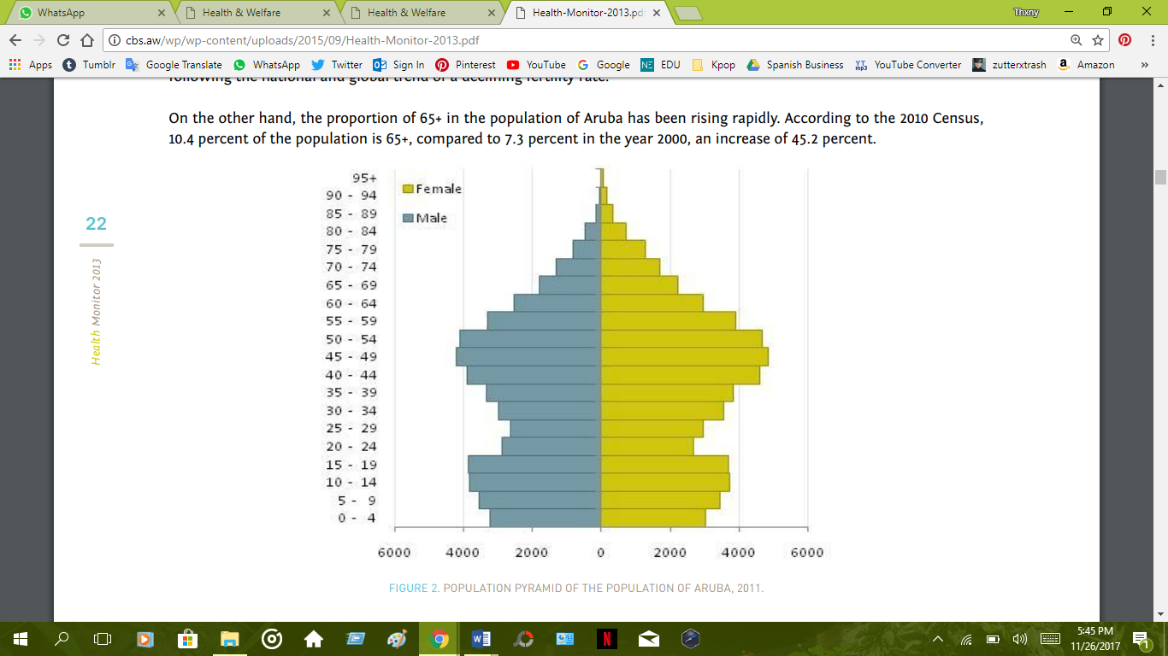  
Figure 1 Source: Health Monitor, 2013

Life expectancy in a country can indicate how well the health care system is. Some people live long enough to see their grandchildren and some sadly don’t live long enough to even say their first word. However in the table below there is an average life expectancy of people on Aruba divided by male and female.

|  |  |
| --- | --- |
| Life expectancy on Aruba | |
| Male | 73.9 |
| Female | 79.8 |

The older people are the more their need for Health care will increase. In this table below I will show you an estimate of how many years there was invested in poor and good health for male and females.

As you can see females were more invested in when it came to poor health and men were less for both poor and good health. For women this could include yearly PAP tests, breast cancer victims and even more invested in birth control.

|  |  |  |
| --- | --- | --- |
|  | Females | Males |
| Poor health | 19.5 years | 15 years |
| Good health | 12 years | 10 years |

The two biggest causes of death in Aruba are: Diseases of Circulatory System🡪 33% and Neoplasms(which are related to cancer)🡪25%  
Aruba should invest more in the prevention of these diseases since they are the most occurred death causes.

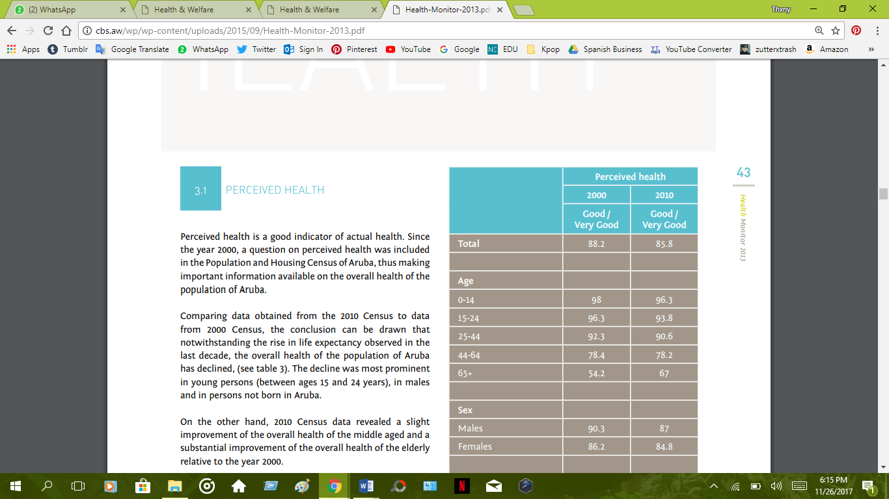

As you can see in the table to the left. The percentage are high until it reaches to the age of 44-64. Which is where people get more symptoms of bad health or diseases.

But one thing that needs attention is that from 2000 to 2010 the perceived has declined which means that there must be something wrong. Instead of decreasing the percentage of perceived health it has declined meaning there is a lack in our health care system

Source: Health Monitor, 2013

In this graph it shows the amount of people in Aruba that have syphilis. Syphilis is the most common sexual transmitted disease in Aruba. Most of the infected are men but you can see at the age of 15-24 there are more females with this diseases compared to men.   
I believe that this is really serious because they are really young and still have a life ahead for them. Young girls should be education in a better and effective manner since they get infected at such a young age where they barely started to have sex.

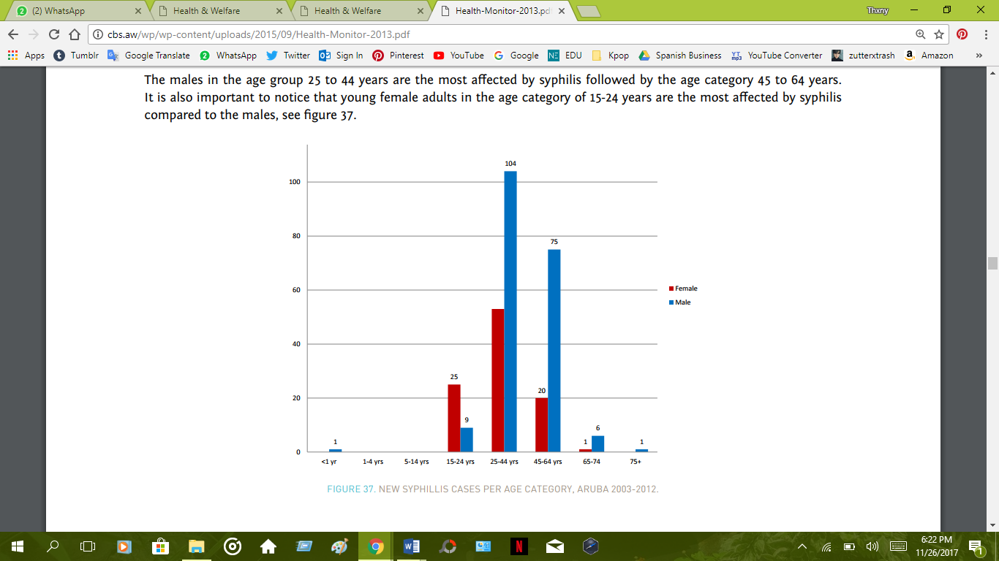

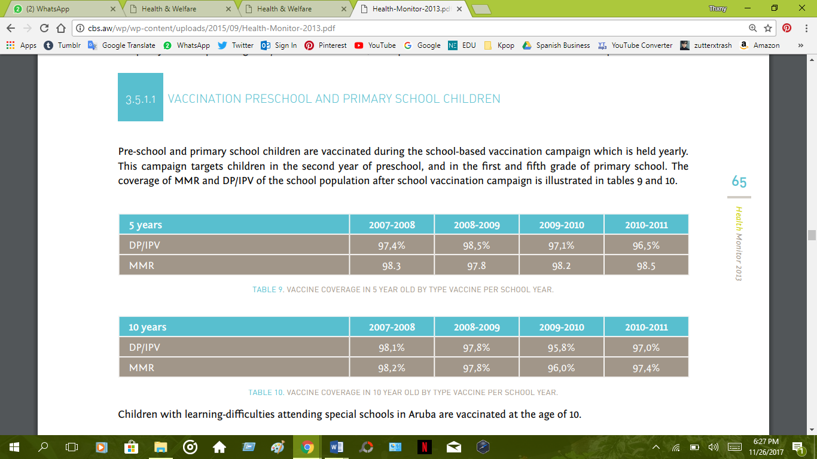

Source: Health Monitor, 2013

The table above indicates that the majority of children have been vaccined which is something great that our health care system provides.

**Health care provided in Aruba**

In 2011 there was 39 General care practitioners on this island providing care for the people. Most GP are located the “pabou di brug” which were the population is really high. Majority of this area is covered by insurance. There is first line and second line of care. First line can be contacted by patients, which are house doctors, dentists etc. Second line care are more specialized doctors, which you need a letter of recommendation of your current house doctor. Special care is not provided on the island which is why people with serious health problems have to go abroad.

# Bibliography

Visser, R. (2013). *Health Monitor.* Aruba.

*SDG Aruba*. (n.d.). Retrieved from Good health and Well being: http://sdgaruba.com/sdgs/health/

*Sustainable Development Goal 3*. (n.d.). Retrieved from Sustainable Development UN: https://sustainabledevelopment.un.org/sdg3